https://static.wixstatic.com/media/159a5b_034912787fe94ea0a69a2fd89cc7af1c.png/v1/fill/w_54,h_54,al_c,usm_0.66_1.00_0.01/159a5b_034912787fe94ea0a69a2fd89cc7af1c.png 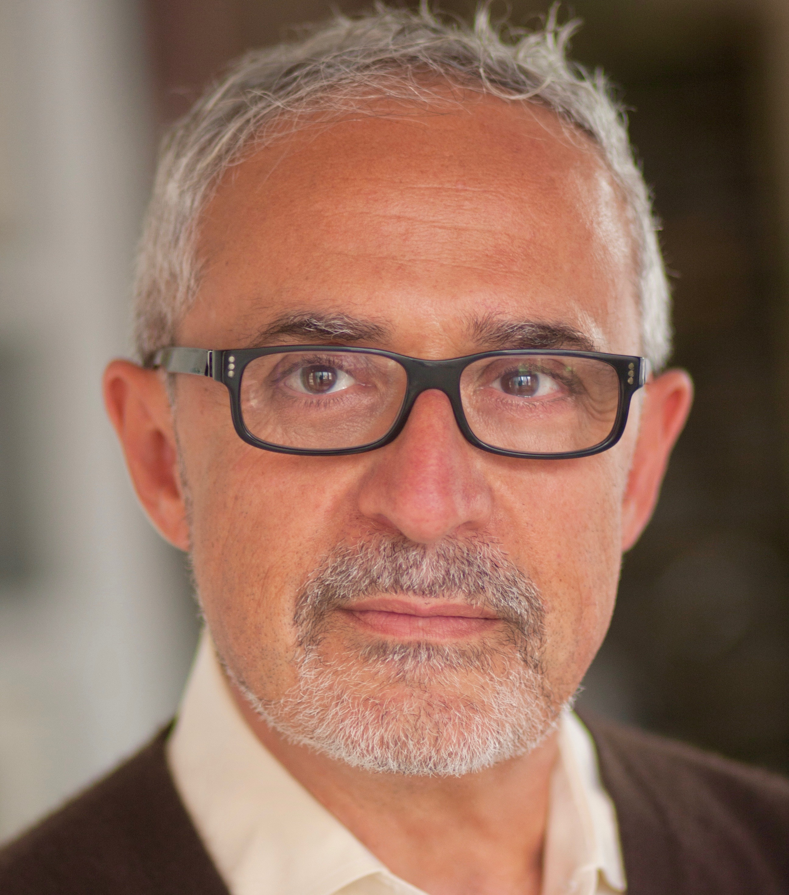

**ANTON OBEID**

[**www.AntonObeid.com**](http://www.AntonObeid.com)

[**antonobeid@gmail.com**](mailto:antonobeid@gmail.com)

**917.497.7034**

**Special Skills**

Fluent in English, French and Arabic; Fencer, expert skier; tennis player; swimmer; certified sailor.

Skied the French, Austrian, and Italian Alps. Sailed the Magellan Strait in Patagonia/Tierra Del Fuego. Hiked the Arctic Circle. Climbed Kilimanjaro. Ran the Milford Track to the Tasman Sea & Bungee jumped 300 Ft into Skippers Canyon, Queenstown, NZ.

**Film** *(2013 – present)*

|  |  |  |
| --- | --- | --- |
| Fish Bones | Co-star | Joanne M. Park / **Slamdance Film Festival** |
| Tarab | A Lead | Jennifer Hanley / Ally Artists / **NY FF** |
| Last Night | A Lead | Arlen Konopaki / **Toronto Film Festival** |
| Front of House | A Lead | Jennifer Azano / Ryan Preimesberger |
| 36 Saints | Hotel Manager | Eddy Duran / Joey Dedio |
| The Dictator | New BBC Interviewer | **Larry Charles / Sacha Cohen / Paramount** |
| Ticket Shack | Lead | Uri Aran / **Frieze Art Fair New York** |

**TV** *(2015 – present)*

|  |  |  |
| --- | --- | --- |
| Law & Order: SVU | Co-Star | **Constantine Makris / NBC** |
| Blue Bloods | Co-star | **David Barrett / CBS** |
| Ramy | Co-Star | **Harry Bradbeer** / **Hulu** |

**Audio** *(2019 – present)*

|  |  |  |  |  |
| --- | --- | --- | --- | --- |
| Aliens of Extraordinary Ability | | A Lead | | Elisabeth Durkin/ Shaina Feinberg **/ Audible** |
| The Negotiator / Beirut | ADR French/Arabic/Eng. | | B. Anderson / **Kasbah Film / Edinburgh FF** | | |

**Theatre** *(2015 – present)*

|  |  |  |
| --- | --- | --- |
| Walls *Summer Awad* | Baba (A Lead) | FringeNYC / David Paul Ratliff |
| Le Problème *François Bégaudeau* | Alban (Lead) | ARACA Project – In French & English |
| The Second Collection *Drew Keil* | Pro & Antagonist on alternate perfs | Artistic New Directions / Gene Santarelli |
| Many Mansions  *B. McEldowney* | Max Odd (Lead) | Treehouse Thr. / Nicola McEldowney |
| Arsenic and Old Lace *J Kesselring* | Dr Einstein | Times Square Arts Ctr / Mike Cramer |

**Career** *(1986 – 2005)*

|  |  |  |
| --- | --- | --- |
| Morgan Stanley | Executive Director | NY, NY |
| Barclays Capital | Director | London, UK |
| Fuji Capital | Vice President | NY, NY |
| AT&T Bell Laboratories | Consultant | NY, NY |

**Education** *(1976 – 1986)*

|  |  |  |
| --- | --- | --- |
| Masters of Science Computer Science | Columbia University | NY, NY |
| Masters of Science Chemistry | American University | LB |
| Bachelors of Science Chemistry | Washington University, St Louis, MO | MO |

**Training** *(2010 – 2013)*

|  |  |  |
| --- | --- | --- |
| Method Acting | ­­The Lee Strasberg T&F I | Geoffrey Horne, Loros, Irma Sandrey |
| Advanced Scene Study | HB Studio | Austin Pendleton |
| Shakespeare, Chekhov | HB Studio | George Bartenieff, Aleksey Burago |
| Camera & Commercials | HB & NYU | Sam Groom, Mark Blum |
| Accent & Voice Production | Private Training | J. Van Wyden, A. Quaid & B. Baumer |